TCN4211
Telecommunication Networks

Project Title: Hub and Spoke Network Topology

Author Name: Anaisy Garcia PID: 5734454
Author Name: Raymond Piloto PID: 5675143
Author Name: Anthony Rodriguez PID: 5878590



Florida International University
Executive Summary
For this project, we decided at first to implement a manageable system that the three of us could configure properly while also allowing for complexity in the form of extra additions to the network. The hub and spoke model allows for a relatively simple topology, but can also very easily be expanded upon into the network that we have now. It has computers/laptops/ a smartphone, switches, routers, a server, an access point and a printer all interconnected via the use of Router 2 as the ‘hub’, and the other 3 routers acting as the ‘spokes’. Each spoke has their own unique network, but all of the PC’s can communicate with each other in the WAN.
This thought process going into the network of starting from a relatively smaller topology and expanding outward allowed for us to reach the current topology that we have. This instilled a greater sense of discovery and tinkering with Packet Tracer to see how much could be done. Progress was relatively smooth up until the wireless router in our initial topology that we sent in began to cause connection issues from the rest of the network to that router, and inevitably we decided on cutting it and going for the current topology we have, with an added network through an access point. The wireless router was proving too troublesome to connect to the rest of the network so the alternative in our minds was to go beyond the initial topology that we had by using this access point along with a server that allows for email and a website to exist on all the computers.
We implemented all of this through researching what could be done to replace the wireless router and figured that what we have would be best to prove we still put in an effort. Our recommendation for future students working on the project is to essentially push themselves as much as they can within their limits, because it was difficult to work through all of this, and once we realized we couldn’t complete the wireless router we decided to branch out in a different direction.
Project Goals:
The main outcomes expected after completion of the project were to have a better understanding of Packet Tracer, learn teamwork coordination skills in the process, and to test how much we as a group learned in this semester about telecommunication networks.
Equipment
- Cisco Packet Tracer Simulation Software, version 6.2 for Windows, Student Version
- Computers capable of running Cisco Packet Tracer on Windows operating systems.
- The following are all simulated in Packet Tracer: 9 computers, 1 smartphone, 1 printer, 2 switches, 1 access point, 1 server, and 4 routers.

Network Design
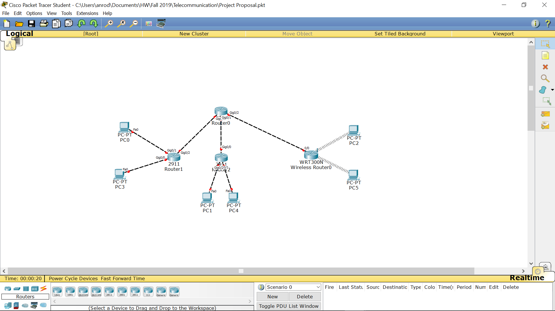
Above was our initial topology, which was much more rudimentary than our final design, because we were unsure how much we were going to be able to configure going forward, and even in this small network, the wireless router proved to be troublesome to ping from outside of its own LAN. In the end, we decided to abandon the use of a wireless router and instead use this as our final topology:

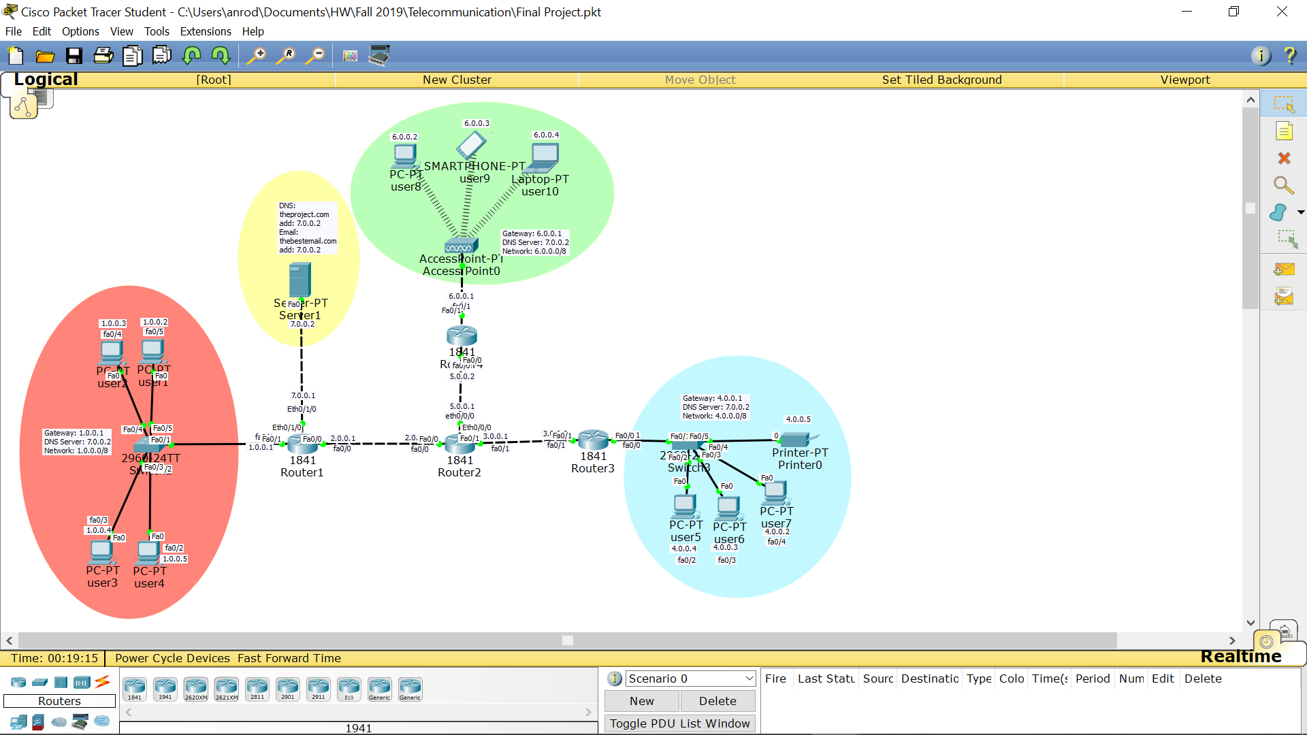
In this topology, it still uses the basic ideas of our initial topology, being a hub and spoke topology with one router essentially being the hub, in this case labelled as Router #2, and the spokes being the routers directly connected to it being Router #1, Router #3 and Router #4, which each connect to their own corresponding LAN’s. Router #’s 1 and 3 use a switch to help regulate their corresponding LAN’s traffic while Router #4 uses an access point. In addition to that, there’s a server which enables email and a website to be used on any of the PC’s in this network and a printer in the router corresponding to Router #3 which can also be used by any PC.
Below are the static IP addresses of the end user devices in the LAN corresponding to Router #1, being 4 computers:
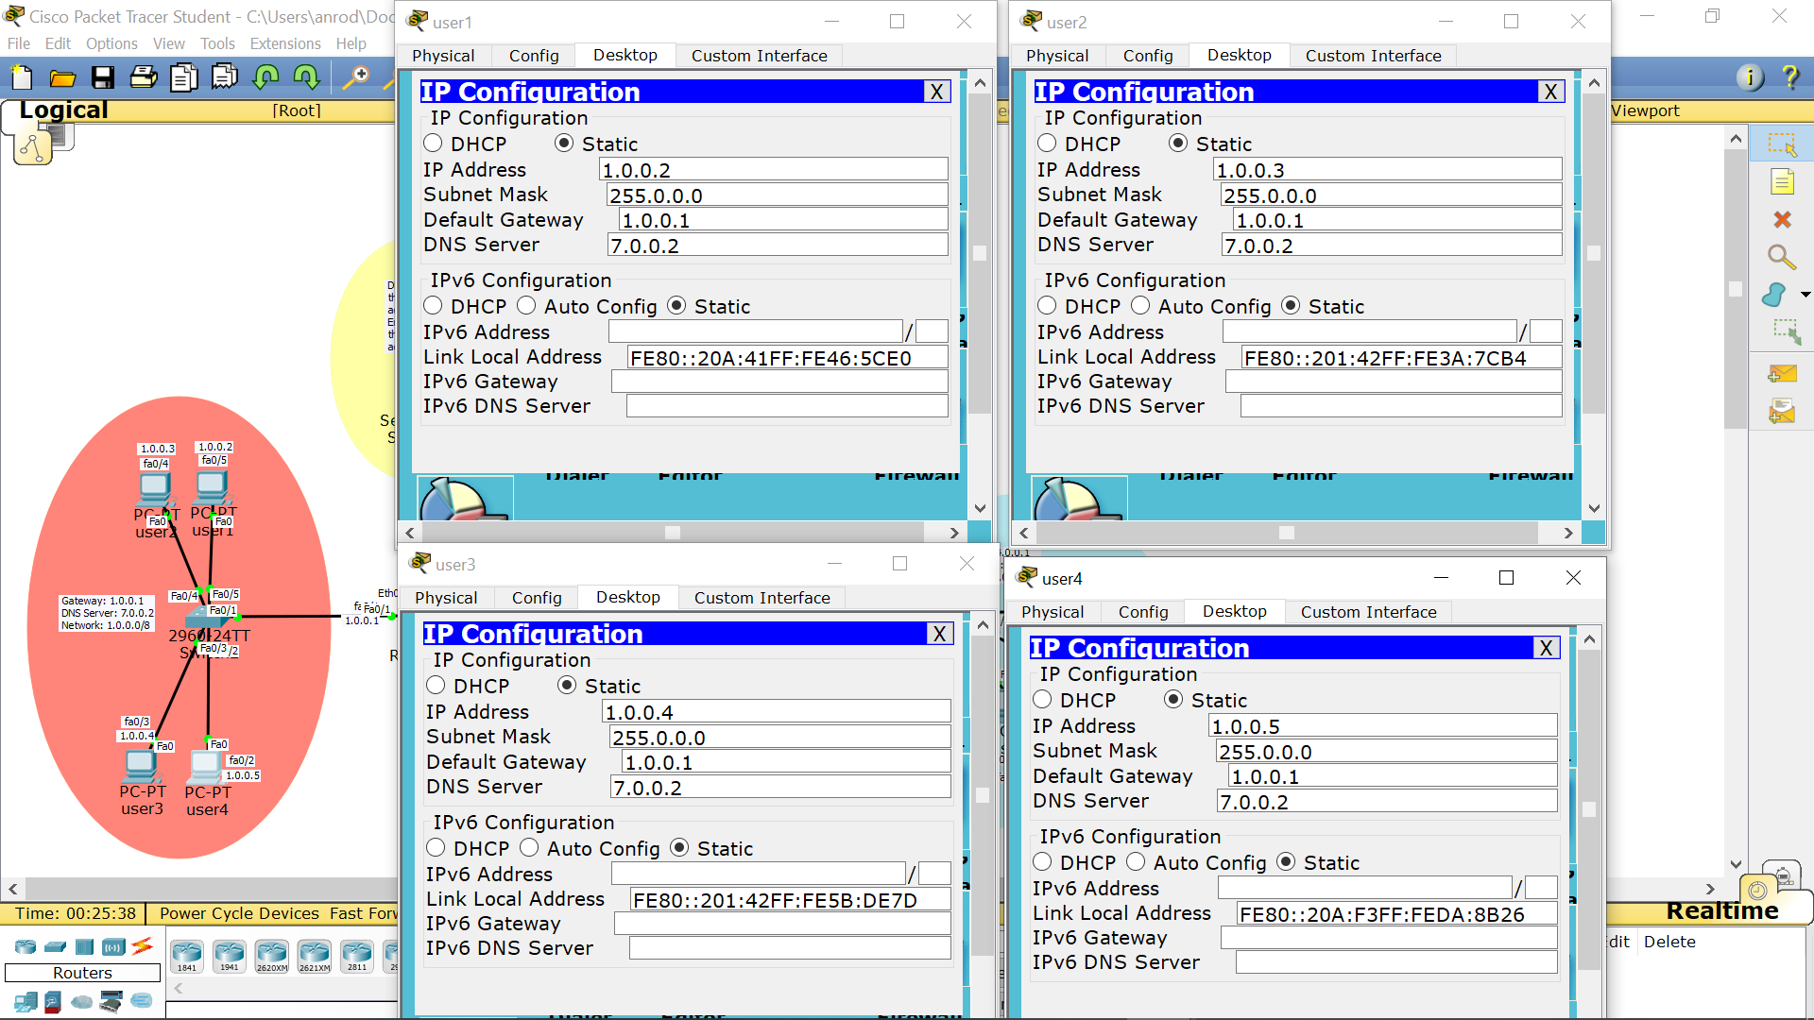
Below are the static IP addresses of the end user devices in the LAN corresponding to Router #3, being 3 computers along with the printer’s configurations:
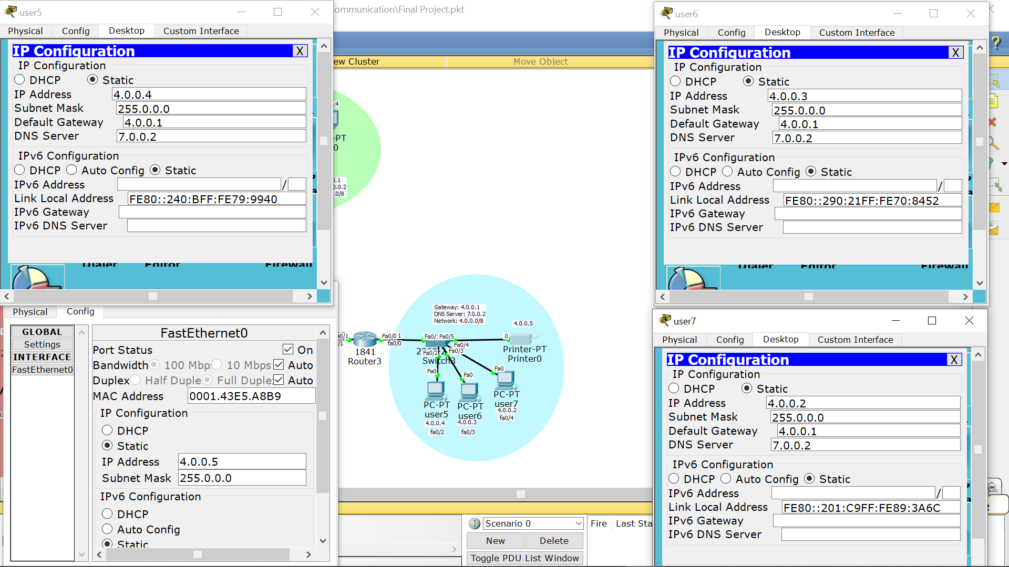
Below are the static IP addresses of the end user device in the LAN associated with Router #4, which consists of 2 computers and a smart phone:
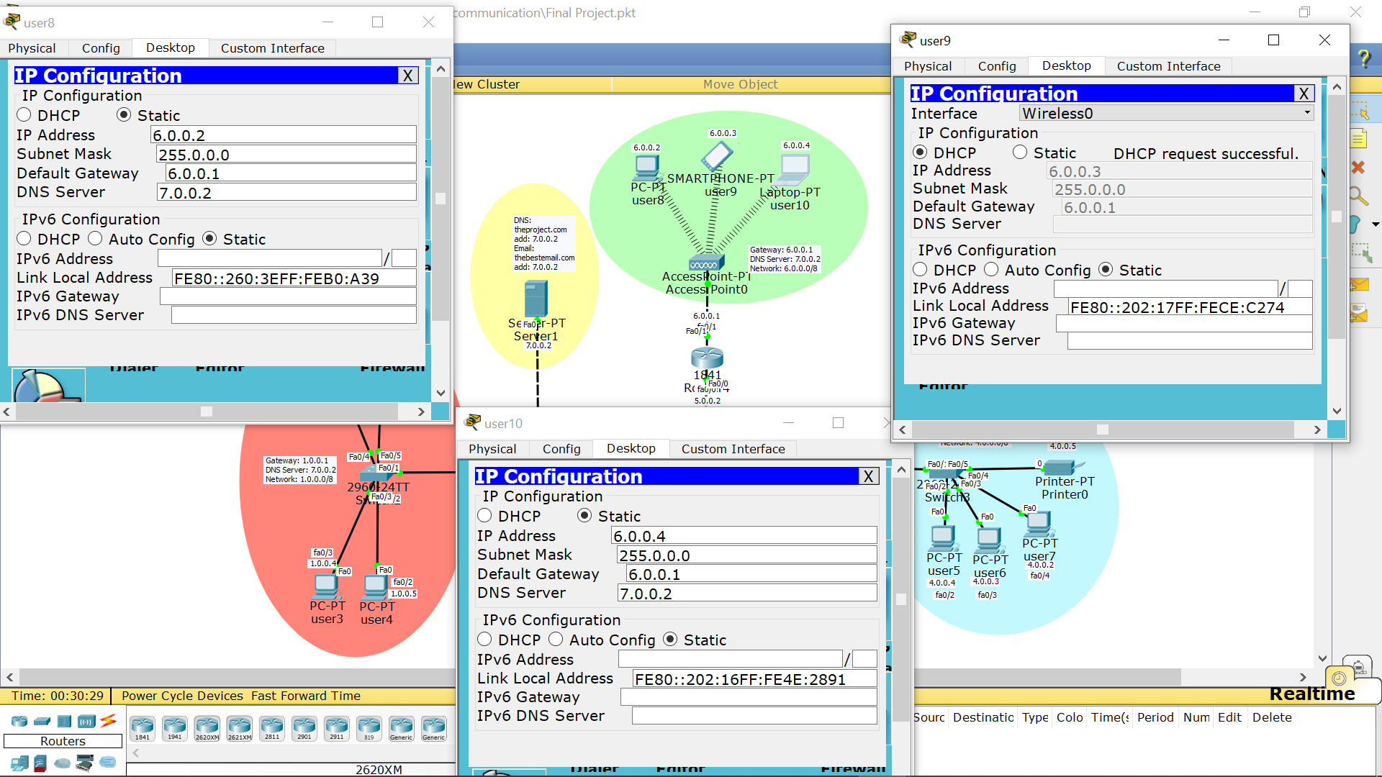
We’ve also included a server that’s also connected to Router #1, whose static IP address is shown below. It’s purpose in the network is to enable emailing and website access through the entire WAN by means of a SMTP service within the server config which helps us set a domain name and individual users for the email and a DNS service within the server config which allows us to create a name for our website and give it an address being the server itself then we use the HTTP tab to configure the HTML for the website itself.
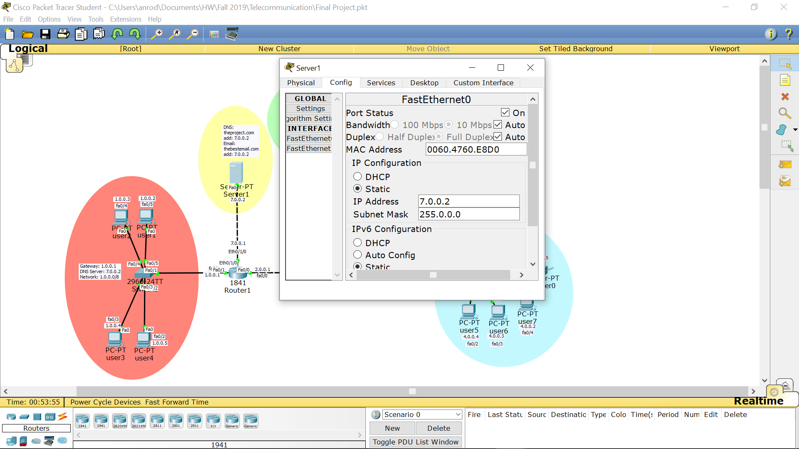

Network Configuration
To configure the first network (1.0.0.0/8), we needed to connect them to a switch to network them then configure each individual PC with an IP address and a subnet mask. This was done using the config tab. The switch was then connected to Router1.
Router1 had only two port initially but this was changed by adding a WIC-1ENET which added another ethernet port. This ethernet port was connected to a server and the other two ports were connected to a switch with a network already and another router. The configuration for router1 is as follows:
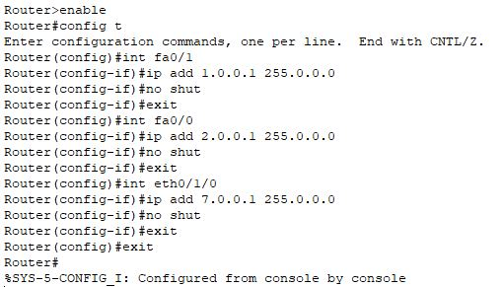
Server1 was configured to gateway 7.0.0.1 of port eth0/1/0 of router1. The IP address, gateway and subnet mask were configured through the config tab. The server can also provide an email, DNS, and HTTP service. These were configured using the services tab. Email was configured using the email subsection in the services tab. Here we put on for SMTP and POP3 then we establish a domain name and set up each user with a username and password.
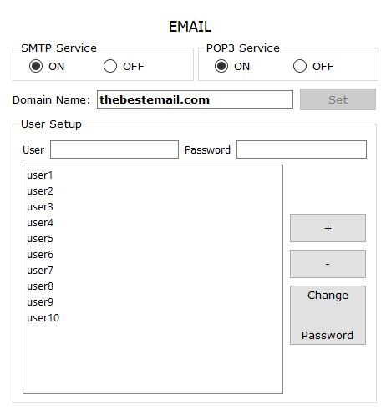
From here each individual user was set up with the appropriate information in desktop then email.
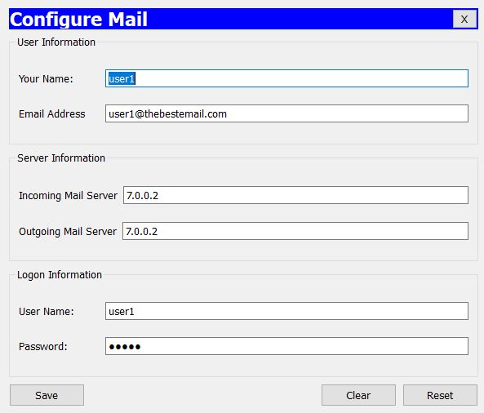
For the website, the DNS and HTTP services were used. For the website to work first we needed to create a DNS this was done by turning on DNS then setting a name for our website and the address it is located. After this we needed to go into each individuals users config and add the address for the DNS server.
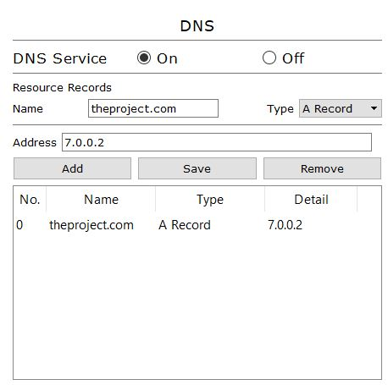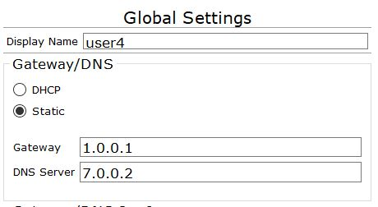
After the DNS was configured the actual website had to be created this was done using the HTTP subtab. Here we set HTTP and HTTPS to on then we delete everything under file manager but the index. Here we write the code in HTML that creates the website.
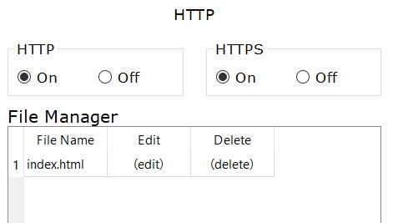
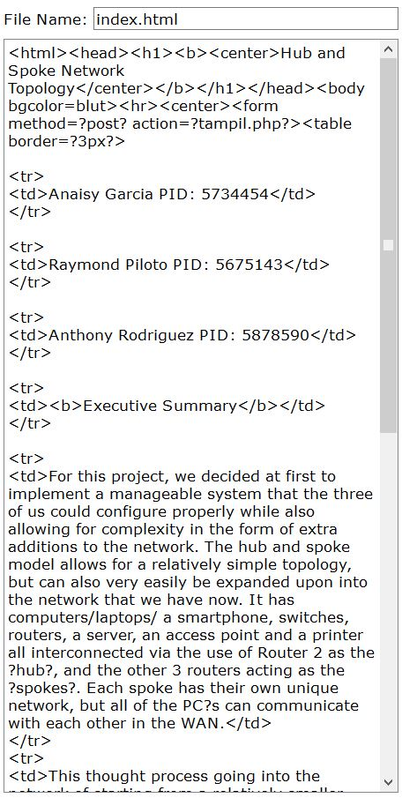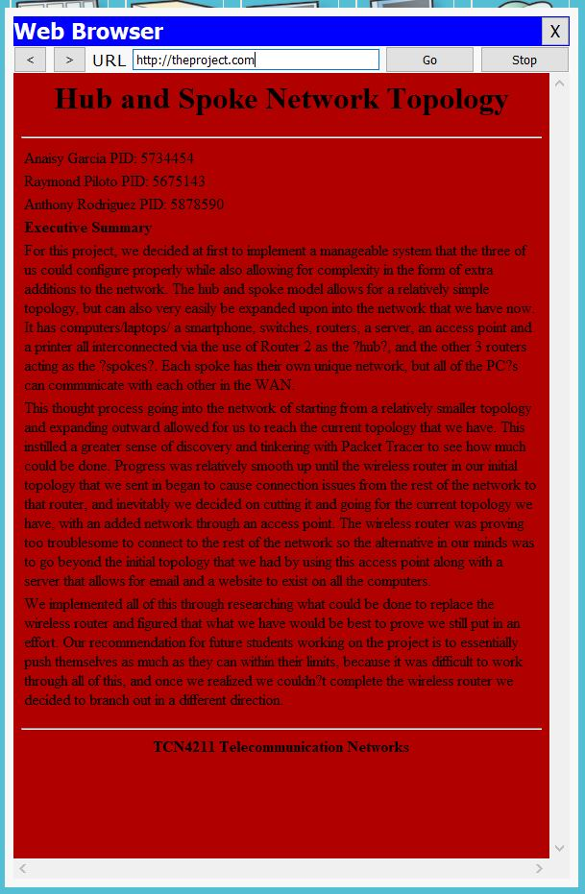

Copy of code used:
<html><head><h1><b><center>Hub and Spoke Network Topology</center></b></h1></head><body bgcolor=blut><hr><center><form method=?post? action=?tampil.php?><table border=?3px?>
<tr><td>Anaisy Garcia PID: 5734454</td>
</tr>
<tr>
<td>Raymond Piloto PID: 5675143</td>
</tr>
<tr>
<td>Anthony Rodriguez PID: 5878590</td>
</tr>
<tr>
<td><b>Executive Summary</b></td>
</tr>
<tr>
<td>For this project, we decided at first to implement a manageable system that the three of us could configure properly while also allowing for complexity in the form of extra additions to the network. The hub and spoke model allows for a relatively simple topology, but can also very easily be expanded upon into the network that we have now. It has computers/laptops/ a smartphone, switches, routers, a server, an access point and a printer all interconnected via the use of Router 2 as the ?hub?, and the other 3 routers acting as the ?spokes?. Each spoke has their own unique network, but all of the PC?s can communicate with each other in the WAN.</td>
</tr>
<tr>
<td>This thought process going into the network of starting from a relatively smaller topology and expanding outward allowed for us to reach the current topology that we have. This instilled a greater sense of discovery and tinkering with Packet Tracer to see how much could be done. Progress was relatively smooth up until the wireless router in our initial topology that we sent in began to cause connection issues from the rest of the network to that router, and inevitably we decided on cutting it and going for the current topology we have, with an added network through an access point. The wireless router was proving too troublesome to connect to the rest of the network so the alternative in our minds was to go beyond the initial topology that we had by using this access point along with a server that allows for email and a website to exist on all the computers.</td>
</tr>
<tr>
<td>We implemented all of this through researching what could be done to replace the wireless router and figured that what we have would be best to prove we still put in an effort. Our recommendation for future students working on the project is to essentially push themselves as much as they can within their limits, because it was difficult to work through all of this, and once we realized we couldn?t complete the wireless router we decided to branch out in a different direction. </td>
</tr>
</table></form></center><hr><center><b>TCN4211 Telecommunication Networks<b></center></body></html>
After the server was configured fully, router2 was added to the topology. Router2 was connected to router1, router3, and router4. This was the central router of the topology that brought it all together. This router also had a WIC-1ENET added for another ethernet port. The configuration for router2 is as follows:
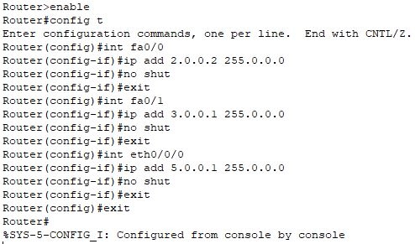
Router3 was the next one configured. This router did not have anything added but it connected to the network 4.0.0.0/8. This was a network of three PCs and one printer connected to a switch. The switch then being connected to the router. These were all configured using the config tab. Here the IP address, subnet mask, and gateway were set this includes the printer as well. The configuration for router3 is as follows:
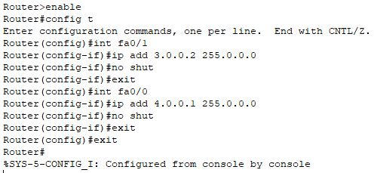
Router4 connected the wireless network to the rest of the topology. This one like router3 had no extra parts installed. This connected to the wireless network 6.0.0.0/8. This network consisted of an access point, a PC, a smartphone, and a laptop. Both the laptop and the PC had installs. The PC had a Linksys-WMP300N installed and the laptop had a Linksys-WPC300N installed. These wirelessly connected through an access point. These were all configured using the config tab. Here the IP address, subnet mask, and gateway were set this includes the smartphone as well. The configuration for router4 is as follows:
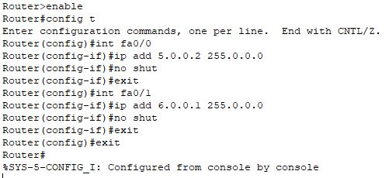
All these routers were then routed using the IP route command as shown below.
Router1:
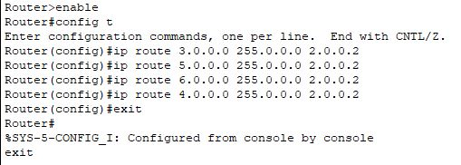
Router2:
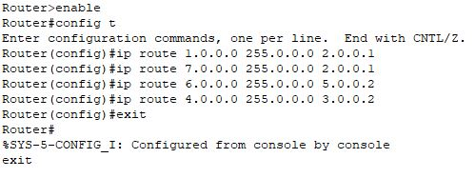
Router3:
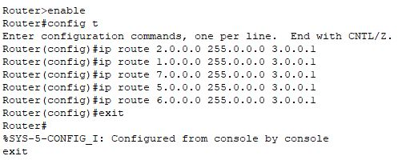
Router4:
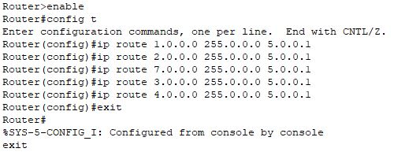
Pings to show successful connections:
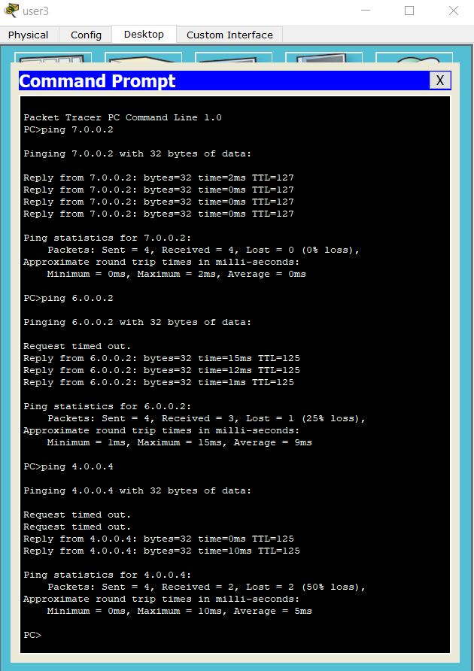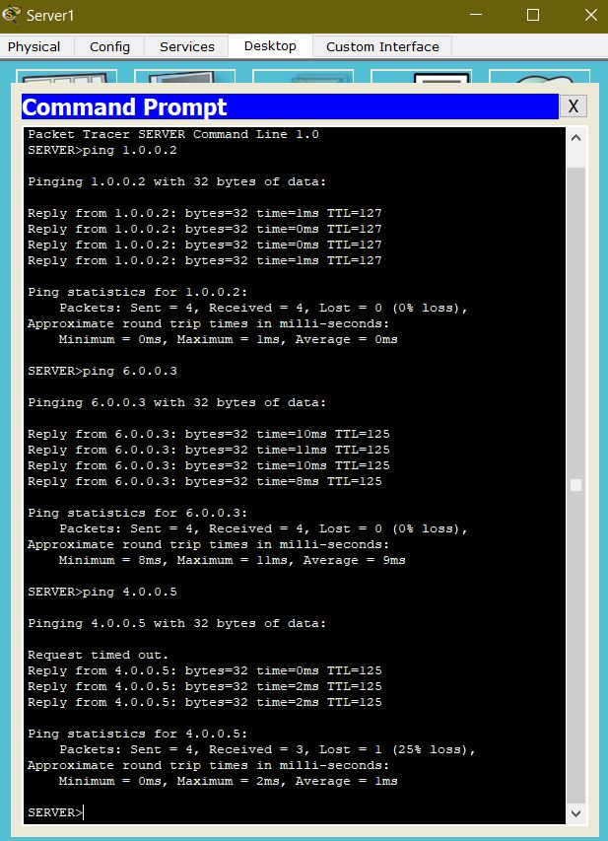
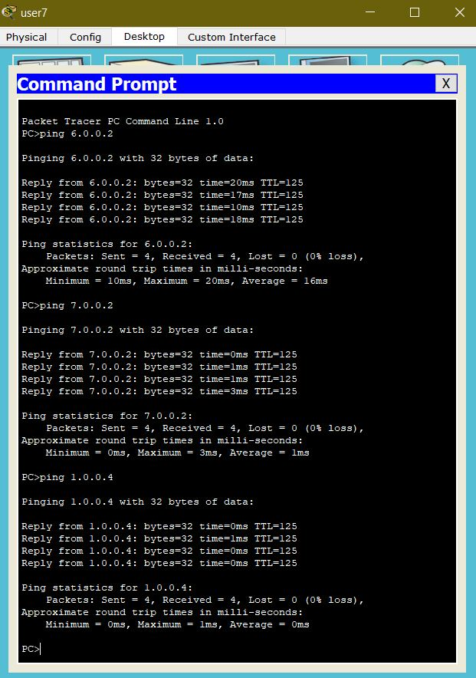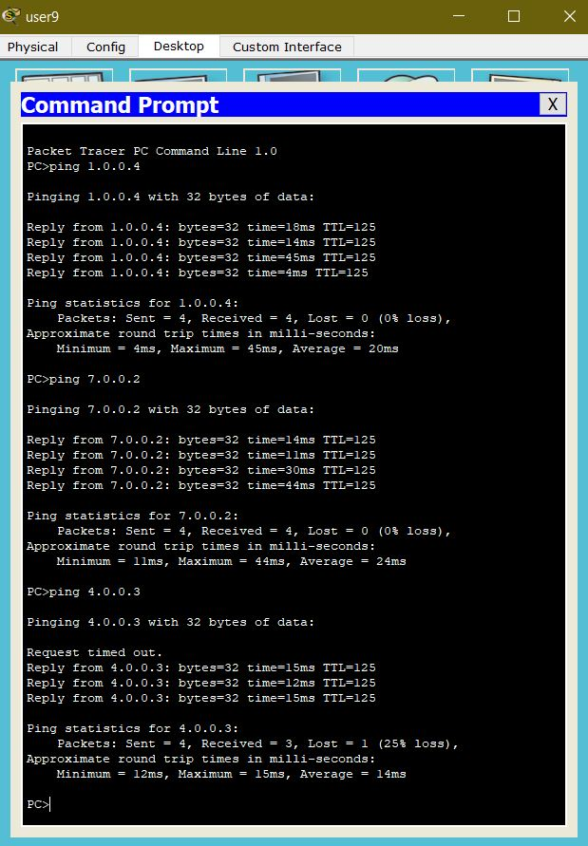

Recommendations and Conclusions
For recommendations, future students working on this project should work in a similar mentality to how we’ve approached it. This project is deliberately open-ended so students can experiment with Packet Tracer and see what they end up with as their final network. As long as the students recognize their limits while also trying their best in creating a fully functional network, the project was a success in our opinion. Our initial topology was very simple in retrospect (apart from the wireless router causing too many problems), so that’s why we decided to expand it as much as we have with our final topology. This benefits us not only in (hopefully) getting a better grade, but also more importantly in learning how networks such as this work in the real world if we were to work in this field, maybe even work towards being certified under Cisco.
The result of our project was that every end user device can ping every other end user device, meaning this network is fully operational. It is useful to us in that we now know that we can manage to configure this large of a network with different components, including features that weren’t taught in class such as emailing. This network’s main advantage is that, at least in terms of it being a simulation, it’s very easy to continue expanding this network for future practice by adding more components. On the downside, since it is still a hub and spoke topology, the network’s traffic may be flooded if the network gets too big. The server could potentially help alleviate some of the traffic, but Router #2 still ends up with having the burden of the entire network. In terms of the project in general, we learned that despite having difficulties with the wireless router, we were able to continue forward and create a larger and more robust network that we can all be proud of.

